Project Design Phase
Solution Architecture

Date
Team ID
Project Name
Maximum Marks | 4 Marks

Solution Architecture:
Solution architecture is a complex process – with many sub-processes – that bridges the gap between business problems and technology solutions. Its goals are to:
- Find the best tech solution to solve existing business problems.
- Describe the structure, characteristics, behavior, and other aspects of the software to project stakeholders.
- Define features, development phases, and solution requirements.
- Provide specifications according to which the solution is defined, managed, and delivered.
Solution Architecture Diagram:
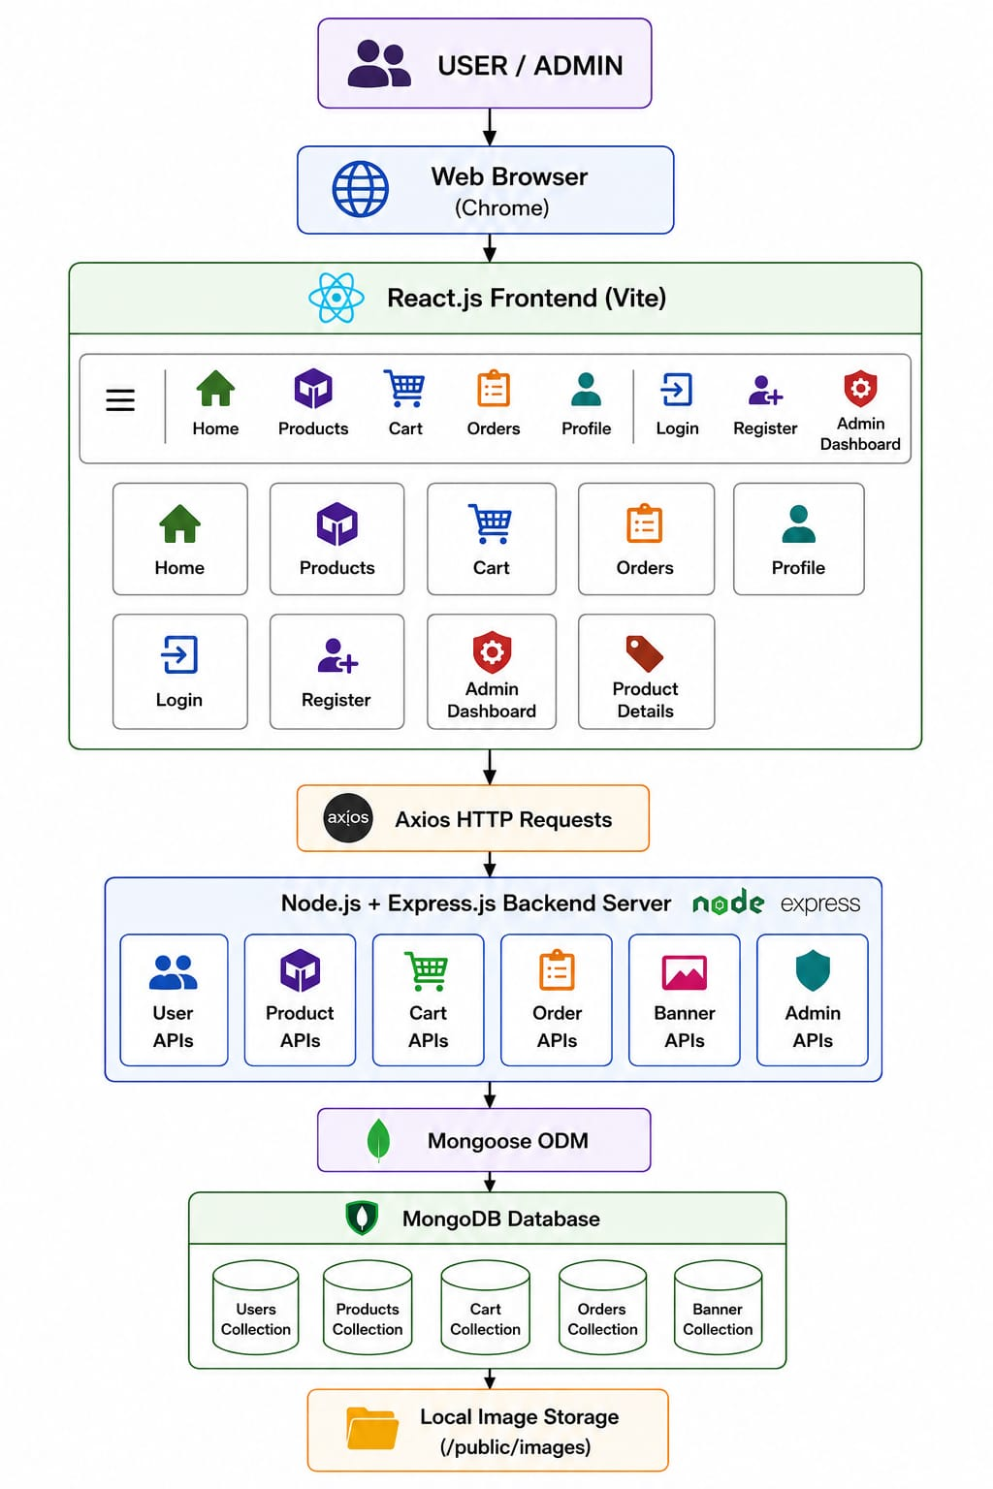
Figure 1: Solution Architecture of the ShopEZ MERN E-Commerce Application
Description:
The ShopEZ solution architecture follows the MERN three-tier architecture. Users interact with the React.js frontend through a web browser. The frontend communicates with the Express.js backend using Axios HTTP requests. The backend processes user, product, cart, order, banner, and admin requests and stores data in MongoDB using Mongoose. Product and banner images are maintained in the local file system under the public/images directory.
Reference:
https://react.dev/
https://expressjs.com/
https://www.mongodb.com/docs/
https://nodejs.org/docs/

